**Market Research**

Our team has been hired by watson games to produce a video game version of a classic board game Clue!, a game that is similar in mechanics to cluedo. In order to properly create our formal requirements document and to choose the best thematic, design and coding solutions for our project, we decided to carry out market research into the most popular video games, board games, and video games based on board games in order to build a solid foundation for our game.

Most popular games on steam

CURRENT PLAYERS PEAK TODAY GAME

1,082,765 1,082,860 Counter-Strike: Global Offensive

548,331 561,707 Dota 2

417,478 417,478 PUBG

211,453 214,368 Apex Legends

162,107 278,801 Valheim

120,673 120,673 Grand Theft Auto V

99,989 145,405 Source SDK Base 2013 Multiplayer

81,924 117,167 Rust

80,007 80,007 鬼谷八荒

77,039 91,281 Team Fortress 2

(Source: <https://store.steampowered.com/stats/Steam-Game-and-Player-Statistics?l=english>) on 11/03/2021 at 14:00)

From studying the top ten most popular games on steam, we can see that all are action games based primarily in the third and first person perspective. Whilst this does not help us with our game design, several patterns emerge from studying each game separately. All of these games have large and loyal player bases due to either paid DLC, a thriving modding community, microtransactions or a combination of the three. This shows that the code must be easy to understand and well documented if we want to open it to the modding community and ensure it has a long shelf life, or to help in the event we want to release further content for the game.

Amazon best sellers in board games

1. UNSOLVED CASE FILES | Ashcroft, Harmony - Cold Case Murder Mystery Game - Can You Solve The Crime? Who Killed Harmony?
2. Orchard Toys Animal Families Mini Game
3. Hasbro Gaming Monopoly Classic Game
4. Thames & Kosmos EXIT - The Game | The Dead Man on the Orient Express
5. Hasbro Gaming Cluedo the Classic Mystery Board Game

Amazon’s most popular list provides us with several viable design decisions for our game. In unsolved case files and Thames & Kosmos EXIT, similar mystery games to Clue!, the designers utilize a more realistic approach to sprite and background design that echoes to modern police and detective dramas. However, Hasbro’s Gaming cluedo, what is our closest competitor, utilizes a more exaggerated yet still somewhat realistic artistic style. It may be best if we distance ourselves from hasbro’s game by either going a similar artistic route as unsolved case files and Thames & Kosmos EXIT, or as discussed below, in a more cartoonish and stylised way

Steam top sellers in board games

1. Tabletop Simulator
2. Jackbox party pack 7
3. Pummel Party
4. Jackbox party pack 3
5. Jackbox party pack 6
6. Uno
7. Jackbox party pack 4
8. Jackbox party pack 5
9. Monopoly Plus
10. Wingspan

Many of the most popular board games on steam, such as jackbox party series and pummel party game tend to use a more cartoonish style of design for their characters and settings. Due to the popularity of these games, I would recommend that we undertake a more cartoon style approach to our art and design section of the game.

Our biggest competitor and what it does right.

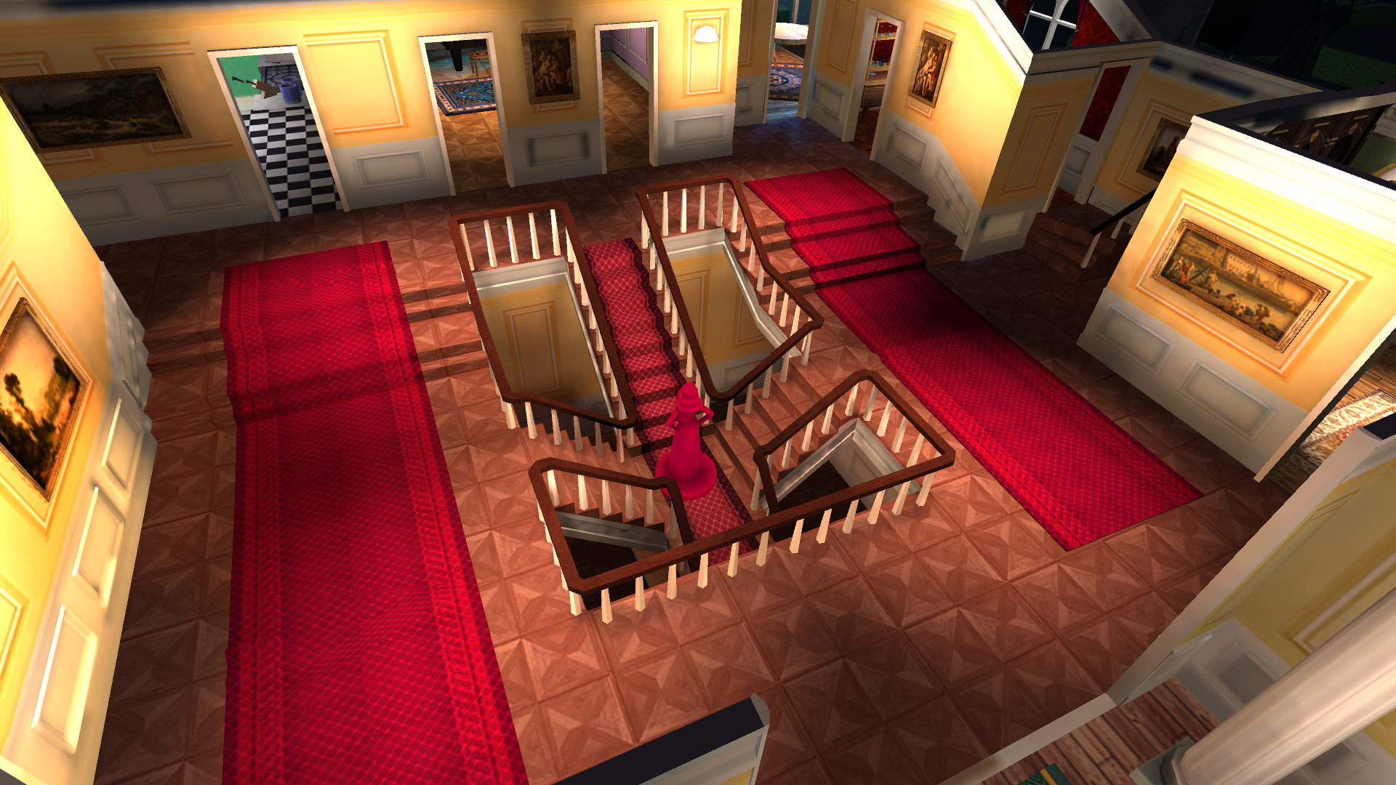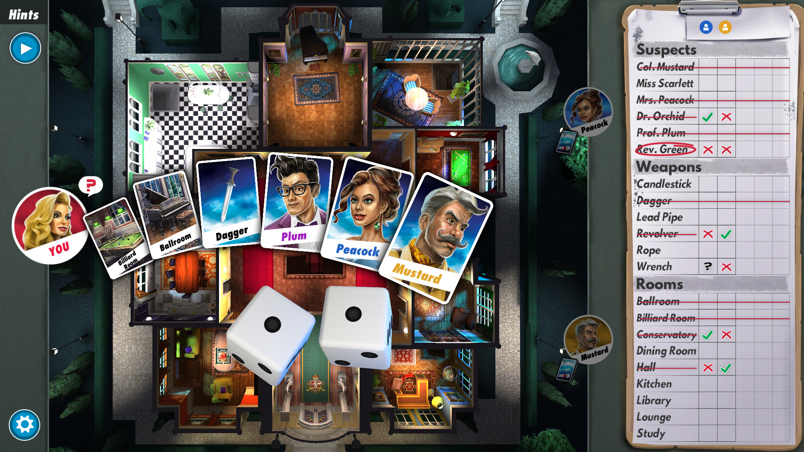

Hasbro’s Clue/Cluedo: The Classic Mystery Game was a very well received game with Overall Reviews being Very Positive (1,184 reviews). I therefore recommend we implement several features from that game into ours such as:

1. Single-player
2. Online PvP (Online multiplayer for up to 6 players)
3. Cross-Platform Multiplayer
4. Steam Achievements
5. Steam Trading Cards
6. In-App Purchases
7. Multiple languages (English, French, Italian, German, Spanish - Spain, Simplified Chinese and Japanese)
8. Single-player against customizable AI.
9. Leaderboards.

